

**Education Resources**

**St. John’s Primary School**

**Hamilton**

**Handbook 2019**

**

*INVESTOR*

**Dixon Street,**

**Hamilton.**

**ML3 6PZ**

**Tel: 01698 283401**

**Fax: 01698 207489**

**e-mail:** [**office@st-johns-hamilton-pri.s-lanark.sch.uk**](mailto:office@st-johns-hamilton-pri.s-lanark.sch.uk)

**Head Teacher: Alison Hope**

*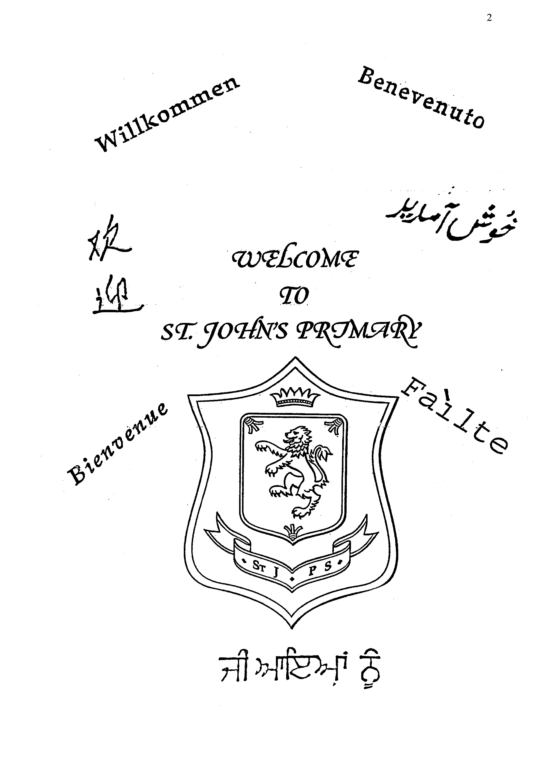***CONTENTS**

**Welcome**

**to**

**St. John’s Primary**

1. Introduction

2. About Our School

3. Parental Involvement

4. School Ethos

5. The Curriculum

6. Assessment

7. Reporting

8. Transitions

9. Support For Pupils (Additional Support Needs)

10. School Improvement

11. School Policies And Practical Information

If you need this information in another language or format, please contact us to discuss how we can best meet your needs.

Phone: 0303 123 1023 Email: [education@southlanarkshire.gov.uk](mailto:education@southlanarkshire.gov.uk).

**1. Introduction**

Introduction by Head Teacher

Dear Parents,

The staff and learners would like to welcome you and your child to St. John’s Primary School. We hope that your association with the school will be a happy and supportive one in which you are encouraged to be active in your child’s learning.

In St. John’s we constantly strive to ensure a positive school ethos exists where all our children and staff are respected and valued and learn in a supportive environment. We promote positive attitudes to learning through a culture of praise and reward whilst developing high expectations of academic achievement and social, moral and spiritual responsibility.

Our Mission Statement is: “Children, staff and parents work together to ensure every child reaches their full potential and leaves with a smile due to the experiences, learning and support they have shared.”

We fully support the purposes and principles of A Curriculum for Excellence to enable our learners to become successful learners, confident individuals, effective contributors and responsible citizens.

South Lanarkshire Council is the fifth largest authority in Scotland. It covers the following main areas; Clydesdale in the south which features extensive rural areas, Cambuslang, Rutherglen, Blantyre and Uddingston to the north as well as the towns of East Kilbride and Hamilton.

The Council’s Plan Connect sets out the Council’s vision which is, “to improve the quality of life for all within South Lanarkshire”.

For Education Resources this means delivering services of the highest quality as well as striving to narrow the gap. It is about continually improving the services for everyone at the same time as giving priority to children, young people, families and communities in most need. The priorities for schools and services are set out in the Education Resources Plan which confirms the commitment to provide better learning opportunities and outcomes for children and young people.

I hope you find the information in this handbook a useful introduction to primary school education in St. John’s. Primary 7 have assisted in the writing of our school handbook which I hope gives you a flavour of how learners feel about our school.

Yours sincerely,

*Alison Hope*

**Head Teacher**

# Welcome from the Parent Council

St. John’s Primary Parent Council plays a supportive role in developing the above aims.

The objective of the Parent Council is to offer all parents the opportunity to have their say in their child’s education. Parent Council members can take forward any educational issues and suggestions on behalf of parents as well as fundraise for the school.

It is easy to get involved. We have meetings about 4 times per year where parents can come along and join in. Keep an eye out for our newsletter and updates on the website.

Thank you to all the parents and staff who have willingly volunteered to become members of our Parent Council. Information regarding the Parent Council constitution and a list of Parent Council members is available from the School Office. Parent Council members can be contacted via the School Office who are also available to answer any questions.

Office bearers are as follows:

**Chair:** Mrs W Christie

**Vice Chair:** Vacant

**Treasurer:** Ms E Smith

**Clerk:** Mrs G Baxter

**Staff Members**

Miss F Moffat

Mrs L Jamieson

St. John`s Parent Council is very active and organises regular social and fund-raising activities such as a sponsored event, book fair, discos and fun days, which are enjoyed by many parents, staff and children. Our Parent Council also continues to liaise with council departments to implement traffic safety measures.

Information updating parents of meetings and events are issued and all parents are encouraged to help and support the council.

Anyone wishing further information or to volunteer is invited to contact the School Office.

[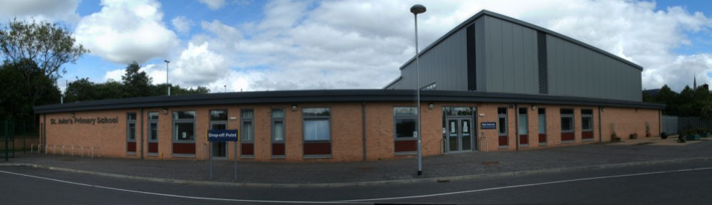](http://st-johns-hamilton-pri.s-lanark.sch.uk/)

**2. About our school**

St. John`s Primary School

Dixon Street

Hamilton

ML3 6PZ

Telephone Number: 01698 283401

Fax Number: 01698 207489

Web Site: <http://st-johns-hamilton-pri.s-lanark.sch.uk>

E-Mail: [office@st-johns-hamilton-pri.s-lanark.sch.uk](mailto:office@st-johns-hamilton-pri.s-lanark.sch.uk)

St John’s Primary is a school with mainstream and ASN classes across all stages, Primary 1 to Primary 7. Our current roll is 311.

***“Practise like you have never won, perform like you have never lost”*** This is our school motto created by Millie Jo Carroll (P7).

We have been awarded the UNCRC (United Nations Convention Rights of the Child) silver Rights Respecting school award and the silver School Sports award. We are working towards gold in both areas.

*“I have the right to an education and I have learned a lot so far.”* Amy primary 2

St Johns has many committees where children’s voices are heard.

Our school is an inclusive, happy and safe environment – we want all learners to be excited to learn.

**

“School is very exciting and I love to meet new friends!” Daniel Primary 1

**Members of Staff**

|  |  |  |  |
| --- | --- | --- | --- |
| **Head Teacher** | Mrs Alison Hope |  |  |
| **Depute Head Teacher** | Mrs Karen Prentice |  |  |
| **Depute Head Teacher (ASN)** | Mr James O’Donnelly | |  |

|  |  |  |  |
| --- | --- | --- | --- |
| **Teaching Staff** |  |  |  |
| Primary 1 | Miss C Kinloch | Primary 5 | Miss F Moffat |
| Primary 1/2 | Miss L Hutton | Primary 4/5/6/7 | Mrs S Carle / |
| Primary 1/2 (Support Class) | Miss N McDonald | (Support Class) | Miss R Young |
| Primary 2/3 | Miss C Young | Primary 5/6 | Mrs L Davis/Miss L Lelland |
| Primary 2/3/4 (Support Class) | Mrs M Palazzo | Primary 6 | Miss L Pinkerton |
| Primary 2/3/4/5 (Support Class) | Mrs E Gallagher | Primary 5/6/7 | Mr A Ewart |
| Primary 3/4 | Mrs L King | (Support Class) |  |
| Primary 4 | Mrs L Mulvenna | Primary 7 | Miss L Shearer |

*Primary 5/6**Mrs L Davis / Miss L Lelland*

*Primary 6 Miss L Pinkerton*

*Primary 6/7 Miss B Lamont*

*Primary 5/6/7 (Support Class) Mr A Ewart*

*Primary 7 Miss L Shearer*

*Class Contact Cover teacher Miss C Primrose /*

**Support Staff**

**Administration Classroom Support Staff**

Mrs S Murray (Team Leader) Mrs F AllisonMrs E Gaffney Mrs J Jenkins

Mrs J IrvineMiss F Bannatyne Mrs M MacLean

Miss L BrysonMrs S BellMrs B McPake

Mrs K Brown Miss L Markey

Mrs L Campbell Mr T Mullen

Ms E Cormack Mrs H Murray

Mrs M Cunningham Mrs J Sneddon

**Early Years Worker** Ms C Haigh

**Janitor** Mr G Robbins

**Visiting Specialists:**

**Active Schools Coordinator** Ms Clare Murphy

**Visiting Music Tutors:**

Cello Mrs R Chalmers

Woodwind Mr M Philip

Viola Mr G Walker

**Management Team Responsibilities**

**All members of the Management Team aim to be supportive and participative to encourage a distributive style of leadership which ensures the children receive the best broad general education possible.**

**Management**

Everyone in the management team has an important role in St John’s Primary School.

**Mrs A. Hope**

Firstly, Mrs A Hope has overall responsibility is St John’s Primary. Mrs Hope helps out all the children and makes sure they are having fun. Mrs Hope organises special and fun events in the school. She helps keep the school clean and safe.

*“I like it when Mrs Hope says good morning to me*” Lexi Primary 5

The **Head Teacher** has overall responsibility for the management and leadership of Staff, Learners, Resources and Budget, Administration, Health & Safety, Security, Curriculum, Child Protection and Communication.

The Head Teacher has a consultative and communicative role with regard to learners, staff, parents, the Learning Community, partnership agencies, Education Resources and the wider community.

Specific responsibility includes:

Improvement Planning Budget

Monitoring Teaching and Learning Personnel / Staff Welfare

Quality Management Equal Opportunities

Primary / Secondary liaison Child Protection

Staff Development

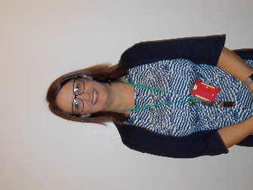**Mrs K Prentice**

Our Depute head teacher Mrs K Prentice helps the head teacher when she needs it. Mrs Prentice leads the Rights Respecting School group which is important in St Johns. If any teacher needs help in class Mrs Prentice will help them. Mrs Prentice will help anyone no matter what and she will put others first.

The **Depute Head Teacher** assists and, where necessary, deputises for the Head Teacher in the overall management of the school.

Specific responsibility includes:

Co-ordinating Support for Learning Raising Achievement & Attainment

Co-ordinating Information and Communication Assessment / Recording / Reporting

Technology Monitoring Teaching & Learning

Whole School Literacy Coordinator Supporting Probationer & Student Teachers

**Mr O’Donnelly**

Our other Depute head Mr O’Donnelly is the ASN depute head. He helps out in all the ASN classes and coaches the boys football team.

*“I like it when he plays his guitar*” Garry Primary 5

The **Depute Head Teacher (ASN)** co-ordinates and supports effective learning and promotes purposeful interaction among learners, staff, parents and partnership agencies.

Specific responsibility includes:

Support for Learning and Inclusion Strategies Co-ordinating extra-curricular activities

Supporting / Monitoring Teaching & Learning Health & Wellbeing

Whole School Numeracy Coordinator

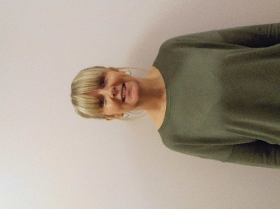**Mrs L Jamieson**

Mrs Jamieson is our Principal teacher and is in charge of Literacy in our school. She is very into the Rights of a child. Mrs Jamieson mainly helps in Primary 1. She helps in the school nativity.

The **Principal Teacher’s** overall responsibility is as a class teacher and, through examples of classroom practice, organisation, display and presentation, to provide support for colleagues.

Specific responsibilities include:j0233956

Supporting Teaching & Learning

Primary/Pre-5 liaison + P1 Entrant Programme

Assessment of P1 learners

Buddy Programme

Example of good teaching practice

**By Blair, Matthew, Robbie, Joshua, Douglas and Runo with addition from Mrs Hope.**

# Parental Concerns

If at any time you have concerns about your child’s welfare or education, please do not hesitate to make contact with the school through the school office, either in person or by telephone. Staff within the school will address these concerns with you in the most appropriate way.

**Complaints Procedure**

If you have a complaint in the first instance please contact the head teacher. If you do not feel the concern has been resolved South Lanarkshire Council have a complaints procedure available online.

**Attendance At School**

It is important for the school to work with parents in encouraging all children to attend school. All absences from school are required by law to be recorded. Absences will normally fall into two categories – authorised or unauthorised absence. In cases where your child is unable to attend school parents are asked to inform us as follows:-

* if you know in advance of any reason why your child is likely to be absent from school, please tell someone at the school, telephone us or let us know in writing. Please also give your child a note on his/her return to school, telling of the reason for absence:
* MCj04040270000[1]notify the school first thing in the morning when your child is going to be absent. Let the school know the likely date of return and keep them informed if the date changes;
* update the school of any change to the following :-
* home telephone number
* mobile number
* emergency contact details
* requests for your child to be absent from school to make an extended visit to relatives must be made in writing to the head teacher, detailing the reason, destination and duration of absence and arrangements for their continuing education.

**We would be grateful for your co-operation with the following procedures:**

* A pupil who needs to leave school e.g. for a medical or dental appointment should bring an appointment card or a parental note.
* **No child is allowed to leave unless accompanied by an adult.**
* Learners must not leave the school grounds at any time between 9 a.m. and 3 p.m. unless they have been given permission to do so, with the exception of those who go home for lunch. If children are going home for lunch, please inform the school by telephone or in writing.

**If you are a new parent to the school, please feel free to telephone the school office at any time to arrange an appointment to have a tour of the school.**

**Medical and Health Care**

If support or advice is required contact details for the school nurse can be obtained from the school office.

Please remember to check your child’s hair regularly for head lice. Treatment advice is available from the School Nurse (via the School Office) or local chemists.

Dental Inspections are also carried out on a routine basis in primary schools for Primary 1 and 7 children and parents are offered any necessary treatment for their children although they may choose to go instead to the family dentist.Parents will be advised by letter of these examinations.

**Illness At School**

If a pupil is ill in the school or has an injury, we will try to phone their parent or guardian. A sick pupil shall not be sent home until a parent or guardian comes to pick them up. In an emergency the school might contact an ambulance to help a sick person. If this is your child, we will tell you straight away.

If your child has any allergies or medical requirements please let the school now and please let us know if your child has to be taken home at any point. Our email address is:

[office@st-johns-hamilton-pri.s-lanark.sch.uk](mailto:office@st-johns-hamilton-pri.s-lanark.sch.uk)

**Emergency Contact**

It is **essential** that parents keep the school informed of any change in:

**ADDRESS, TELEPHONE NUMBER OR EMERGENCY CONTACT DETAILS.**

Please inform the school if your child has any particular **medical requirements** and of any arrangement to be made if your child has to be taken home.

**01698 283401**

In the event of very severe weather it may be necessary to close the school. We ask that all parents/carers make provision for their child to be collected by a known neighbour or adult who can walk to the school and that children are aware of whom this is.

A text and Twitter messages will be sent to parents’/carers’ main contact mobile number informing them of school closure.

**3. Parental Involvement**

South Lanarkshire Council recognises the importance of parents as partners in the education of their child and has published a strategy entitled, ‘Making a difference – working together to support children’s learning’. This is available from the Council’s website: [www.southlanarkshire.gov.uk](http://www.southlanarkshire.gov.uk)

Parents, carers and family members are by far the most important influences on children’s lives. Children between the ages of 5 and 16 children spend only 15% of their time in school! Research shows that when parents are involved in their child’s learning, children do better at school and throughout life. Parental involvement can take different forms but we hope you share the same aims and agree that by working together we can be partners in supporting children’s learning.

As a parents/carers we want you to be:

* Welcomed and given an opportunity to be involved in the life of the school;
* Fully informed about your child’s learning;
* Encouraged to make an active contribution to your child’s learning;
* Able to support learning at home;
* Encouraged to express your views and involved in forums and discussions on education related issues.

To find out more on how to be a parent helper, or a member of the Parent Council just contact the school or visit our website.

Some useful information contacts for parents to find out more on education are as follows:-

* Parentzone – [www.parentzonescotland.gov.uk](http://www.parentzonescotland.gov.uk)
* Engage Parent Forum – [www.engageforeducation.org](http://www.engageforeducation.org)
* National Parent Forum for Scotland – [www.educationscotland.gov.uk/parentzone](http://www.educationscotland.gov.uk/parentzone)
* South Lanarkshire Council – [www.southlanarkshire.gov.uk](http://www.southlanarkshire.gov.uk)
* St John’s Primary Hamilton - <http://st-johns-hamilton-pri.s-lanark.sch.uk>

We have a fantastic school website to keep all stakeholders updated about events in our school.

It is a great source of information. Please make this your first port of call for all general information, holiday dates, menus and class activities. Why not add it to your favourites for ease of access.

Please sign up to our Twitter feed which will update you when a new item is placed on our website.

**4. School Ethos**

**School Ethos**

At St John’s Primary School, we are keen to know about our rights as a child and have archived our **silver award** and working towards gold. We also have Talking Teams that everyone is involved in such as Eco, Sports committee and Rights Respecting School. Everyone is really working hard in their team to improve all aspects of school life. Team members change every year.

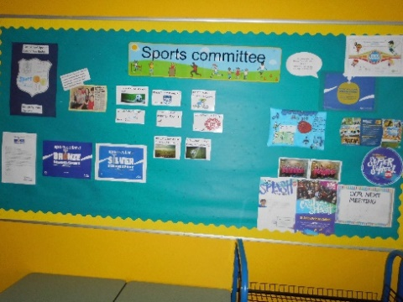

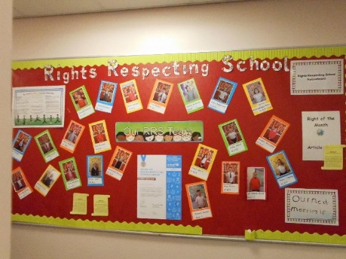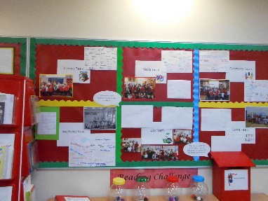

At the start of the year the Primary 7s will meet their buddies, play with them to make them feel welcome!

In St John’s the teachers are very welcoming to all learners. We have 48 members of staff. In fact the whole school is welcoming including janitors, dinner ladies and our new lollipop man, David. We appreciate them very much and all they do for us!

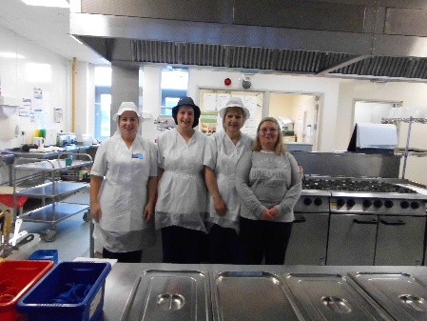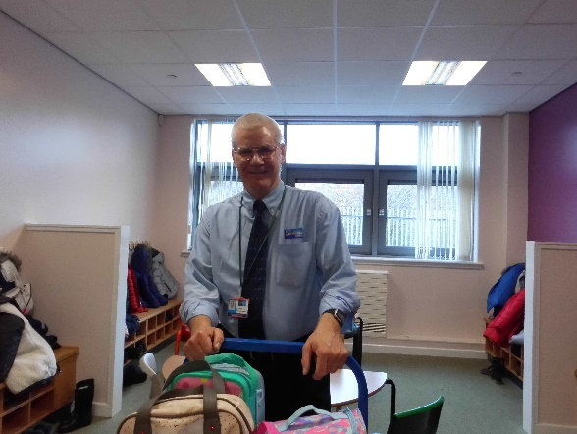

In our school you already know that we are into our rights! So each class designs, creates and signs our class charter. Throughout the year everyone will follow the rights that are on the class charter. We like to have a theme for each class to make them different and unique. Here are some of our favourites!

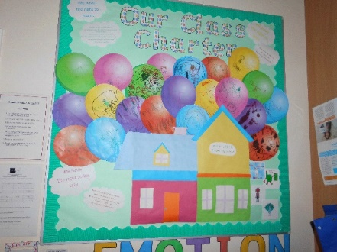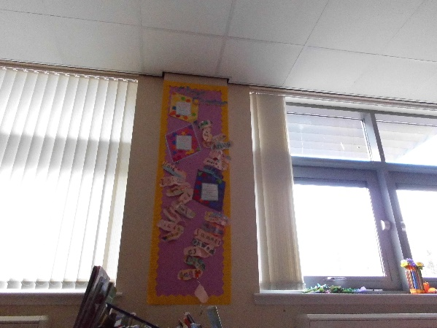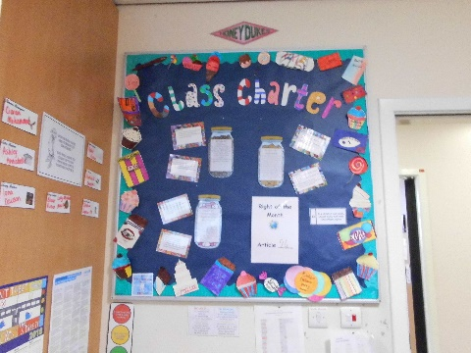

In our school we have four houses: Iona, Skye, Seil and Arran. Everyone is in a house and every week we have a new house focus.

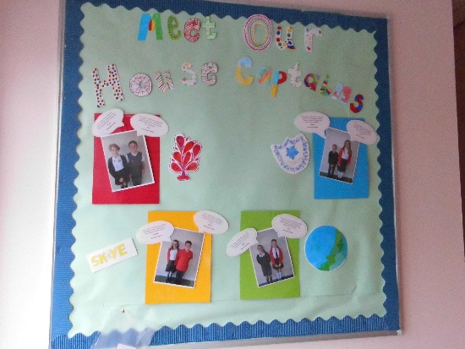House colours are:

Skye – yellow

Seil – green

Iona – blue

Arran - red

**By Sophie N, Stephen, Lorna and Anna**

**Supported Classes**

Our Supported classes opened in August 2000. There is provision for up to 46 learners ranging from P1-P7 with a wide range of additional support needs. The learners are supported in 5 classes with a maximum of 10 or 6 learners in each class staffed by a teacher and appropriate support staff. One of our Depute Heads, Mr James O’Donnelly, has responsibility for the Additional Support Needs classes.

**Inclusion**

Every pupil in St. John’s Support for Learning Unit is given the same opportunities as their mainstream peers to participate fully in all aspects of the school’s activities and to attain his/her potential in all areas of the curriculum.

At present learners are included in assemblies, whole school activities, educational visits, free play activities, break times and lunchtimes. Inclusion in other curricular areas is tailored to meet the needs of each pupil through individual, group or whole class opportunities.

**Parents**

A home/school diary is used to exchange information between parents and staff and we encourage all parents to read and contribute to this frequently.

**Visiting Support Services**

Staff in the Supported classes work closely with a range of professionals, e.g. Educational Psychologist, Speech and Language Therapist, Occupational Therapist, Physiotherapist and the Sensory Impairment Service, to support the individual needs of all learners.

**5. The Curriculum**

**The curriculum**

In our school we use lots of resources to provide your children with the best possible education. Our staff are supportive and very friendly.

- “I like gym time because it is fun.” Erin, Primary 1

“I like maths because it is challenging.” Max, Primary 6

“I like learning new sounds.” Ember, Primary 1

Our school is very open and inclusive for children who need more help than others. We use lots of different strategies to encourage the children to learn such as:

* 5-minute box
* Toe by toe
* Code cracker
* Tee Jay

Education will allow them to become successful learners, confident individuals, responsible citizens and effective contributors.

The curriculum areas that we teach are…

* Expressive arts
* Languages and literacy
* Health and wellbeing
* Mathematics and numeracy
* Religious and moral education
* Science
* Technology
* Social studies

“I like the RRS ethos and everyone in St. Johns is valued and listened to.” Mrs Prentice

“My favourite subject is science because you get to do fun things” Millie Primary 7

**By Ashley, Millie, Lucy M, Zara and Ciaran**

**Spiritual, Social, Moral and Cultural Values (Religious Observance)**

**Rights of Parents / Carers**

Scottish Government Ministers consider that religious observance complements religious education and is an important contribution to learners’ development. It should also have a role in promoting the ethos of a school by bringing learners together and creating a sense of community.

There is a statutory provision for parents to withdraw children from participation in religious observance. This right of parents’ wishes will be respected.

Where a child is withdrawn from religious observance parents will make suitable arrangements for the child to participate in a worthwhile alternative activity. Normally this activity will be undertaken outwith the classroom.

**School Chaplain**

Our school Chaplain is Joanne Hood from St John’s Parish Church.

Joanne attends Friday assemblies when she can and visits classes when they are working on a topic that she can have an input to. Children walk to St John’s Church for the Easter and Christmas services.

**Equalities**

Integral to this guidance is the principle of mutual respect. The diversity of belief and tradition provides an ideal context in which learners can learn about, and so learn from, what is important in the lives of themselves and others. South Lanarkshire’s guidance recognises and welcomes diversity and promotes respectful understanding.

**Parents may request that their children be permitted to be absent in order to celebrate recognised religious events. Advance notice should be provided to the school when children will be absent. Appropriate requests will be granted and the pupil noted as an authorised absentee in the register.**

**6. Assessment**

**

Teachers assess a pupil’s progress by a number of methods which include observation, discussion and specific tasks. The day-to-day aim of teaching is to ensure learners are continually being faced with tasks which they find challenging but attainable. Assessment processes are used to enable teachers to plan and provide appropriate work for learners, assist teachers in diagnosing difficulties individuals may be having and to build up a picture of general aspects of a child’s development such as attitude to work, application, initiative and relationships with adults and peers. Learners’ attainment levels and achievements are reported to parents via written reports or Open Evenings.

Primary 1 learners are assessed before Christmas to ensure that all are making appropriate progress in reading, phonics and number.

Primary 1, 4 and 7 learners are assessed in March/April for reading, writing and numeracy using Scottish National Standardised Assessments, again to ensure that appropriate pace, challenge and supports are in place.

All learners are assessed for Numeracy at the end of a teaching block to ensure that they have acquired the appropriate skills and understanding. All learners are assessed for Writing in September, December and April. Children’s progress is regularly tracked and monitored by the Senior Management Team.

**Formative Assessment**

An important part of learning is being aware of what you learn, how you learn and what helps you learn. Through the use of Formative Assessment, children become aware of strategies which will help them take more responsibility for their learning and participate more in the process of learning.

At the start of important lessons the learning intention is shared with the children and learning targets are discussed and worked on. In employing strategies such as these children learn to evaluate, for themselves, their capabilities and what they need to do to progress.

Children work collaboratively with staff to set termly targets in their learning target sheets which go home at the start of each term, one copy to be kept by the parent and one copy to be returned, signed, to school.

Children also learn to assess aspects of their own and other’s work. In so doing, they gain an understanding of the next steps in learning. Therefore assessment becomes an integral part of the learning process for both the learner and the teacher.

**7.** **Reporting**

Reporting will be ongoing and comprise of a range of activities which can include children presenting their learning, newsletters, report cards, phone calls and ongoing oral discussions.

We will provide parents with reports so that you can see what your child is doing and how they are progressing. In addition, there will be parents’ meetings which offer you the opportunity to discuss how your child is progressing and how you can contact the school if you wish further information. The school will offer you an appointment time so that you can visit in person to discuss your child’s education. **There is only one appointment offered on Parent’s Evenings** **for each child.**  But if parents wish to have separate appointments an alternative time can be arranged through the school office.

Our ‘pupil reports’ will help you to get to know more about the curriculum which each child follows and will describe their strengths, achievements and areas for development so you know what encouragement and support you can give. Full pupil reports are sent home with children in May/ June.

We welcome any comments or additional information from parents to help us provide the best possible education for your child.

**8. Transitions**

**Transitions**

If you don’t live in the local area you can put a placing request to join our local High School.

Primary 7 go to Hamilton Grammar to get used to the High School and all the different classes. We visited Hamilton Grammar to do a treasure hunt and Primary 7 are looking forward to doing our two-day visit.

Recently Primary 6 and 7 have been helping a local charity called Starchild. All the children that will go to the Hamilton Grammar were split up and we did lots of fun activities. We got to show these off at Hamilton Grammar.

“I am excited about going to high school because I met new friends at the Starchid and we will meet again soon!” Morgan Primary 7

“I am excited about going to high school because I will learn more things” Angela Primary 7

“It will be nerve-racking because I don’t know everyone there” Hollie Primary 7



**By Hollie, Angela, Morgan, Mohammad, Serena and Annabelle**

Learners normally transfer from primary to secondary school between the ages of 11½ and 12½, so that they will have the opportunity to complete at least 4 years of secondary education. Arrangements are made by the school to transfer children to the associated secondary school as determined by their home address. Parents of P7 children will be informed of the transfer arrangements made for their child to attend secondary school.

We will also provide you with information at this time and on events designed to let P7 children visit the secondary school to meet up with other P7 children from other schools so that the transition period is as smooth as possible.

Normally children attend the school in their catchment area. However, there are times when parents may wish their children to go to other schools. If you wish your child to go to another school then you may make what is known as a ‘placing request’. If you live in South Lanarkshire and decide to submit a ‘placing request’, we are unable to reserve a place in your catchment school until the Council have made a decision on the ‘placing request’. Please note if your ‘placing request’ application is unsuccessful and all places at your catchment school are filled you will be offered a place at the next nearest appropriate South Lanarkshire School.

Please note that if an application for a ‘placing request’ is successful then school transport is not provided.

If you move outwith your catchment primary school a ‘request to remain form’ must be completed. If you move outwith your catchment primary, this may affect your right to transfer to the associated Secondary School. Please note the secondary school is determined by the pupil’s permanent home address and chosen denomination. If you require further information, please contact Education Support Services on 0303 123 1023.

**Primary/Secondary Liaison**

Our associated secondary school is:

**Hamilton Grammar School**

**Auchincampbell Road**

**HAMILTON**

**Telephone: Hamilton 01698 285777**

Links with Hamilton Grammar are maintained through liaison meetings, curriculum discussions, classroom visits by P7 staff to Hamilton Grammar School, visits to P7 classes by Guidance and Departmental staff, attendance at Parental Open Evenings by Grammar School staff and the transfer of information regarding pupil progress, both verbal and written. Hamilton Grammar Learning Community will provide a creative response to support transition. This will include all Primary 6 and 7 learners in a two year programme. Through this joint working children will develop links with staff in Hamilton Grammar School and other children in the Learning Community.

**9. Support for Learners (Additional Support Needs)**

**Getting it right for every child, (GIRFEC)**

Getting it Right for Every Child (GIRFEC) is a commitment to ensure that your child has the best possible start in life and to improve outcomes based on a shared understanding of their wellbeing. Most children make their journey from birth to the world of work supported by family and the universal services of Health and Education. The Named Person in education helps to make sure that the child’s wellbeing is developing. In St John’s Primary the named person is the head teacher. If you have any concerns you should speak to the head teacher who will work with you to address any issues and to ensure that your child gets any help needed at the right time.

**More information can be found on:**

[**www.girfecinlanarkshire.co.uk**](http://www.girfecinlanarkshire.co.uk) **and** [**www.scotland.gov.uk/gettingitright**](http://www.scotland.gov.uk/gettingitright)

**Support for All (Additional Support Needs)**

At some point in their school career, some children may require additional support. The focus of this support may range from a minor difficulty with a new concept or work missed through prolonged absence, to a more specific difficulty which will need specialised help throughout his or her schooling. Some learners will have an Additional Support Plan. Some learners, meanwhile, require an extension of the curriculum to enrich their educational experience. All learners in our supported classes have an additional support plan.

**It is our aim:**

- to ensure that we offer an appropriate curriculum which will meet the needs of all children;

- to provide a support structure which will allow for individual needs to be identified and supported;

- to provide resources to meet these additional needs

- to monitor progress and ensure continuity of learning by means of ongoing assessment and record keeping;

- to maintain effective communication with the parents of children receiving additional support.

Additional Support is provided by class teachers, Depute Head Teachers (who each have a Support for Learning responsibility), a visiting teacher from the Specialist Support Services and Psychological Services.

South Lanarkshire Education Resources have published a series of leaflets available which cover information for parents and carers about the Additional Support for Learning Acts.

Enquire is funded by the Scottish Government to provide information on the framework for supporting children who require additional support for learning and to encourage positive partnerships between families, schools and local authorities to ensure children get the right support.

Enquire – the Scottish advice service for additional support for learning

Enquire offers independent, confidential advice and information on additional support for learning through:

Phone Helpline: 0345 123 2303

Address : Enquire

Children in Scotland

Rosebery House

9 Haymarket Terrace

Edinburgh

EH12 5EZ

Email Enquiry service: [info@enquire.org.uk](mailto:info@enquire.org.uk)

Advice and information is also available at [www.enquire.org.uk](http://www.enquire.org.uk)

Enquire provides a range of clear and easy-to-read guides and fact sheets including the parents’ guide to additional support for learning.

If you would like to order our leaflets, postcards or guides to share with parents and carers of learners in your school, please contact us on [info@enquire.org.uk](mailto:info@enquire.org.uk)

**10. School Improvement**

**School Improvement Plan**

Curriculum development is carefully structured by means of our **School Improvement Plan**, which enables the school to prioritise areas for development within each year through a process of auditing, reviewing, planning, developing and evaluating. Information about the Plan is issued to all parents each year.

Current areas for development include:

**2018/2019**

1. To further develop a culture of ongoing self-evaluation which leads to strategic improvements through teacher participation in Tapestry.
2. To continue to foster an encouraging climate where pupil voice and confidence is paramount and further embed a Rights Respecting school ethos.
3. To further develop innovative practices in active learning and outdoor play as part of the Health and Wellbeing and Literacy and Numeracy Programmes of study.

**2019/2020**

1. To consolidate the impact of work done 2017- 2020 and evaluate attainment and achievement over time.
2. To evaluate the impact of family learning on closing the attainment gap and continue to explore new approaches for the best use of PEF funding.
3. To consolidate the work started in 2018/2019 on Tapestry developing innovative teaching approaches to raise attainment.

**2020/2021**

1. To further develop teacher understanding of pedagogy to raise attainment and embed practice learned from Tapestry.
2. To build upon teacher expertise in analysing data to close the attainment gap.
3. To evaluate and consolidate the development of the teaching of literacy adopting NL Strategies which commenced in 2018/2019.

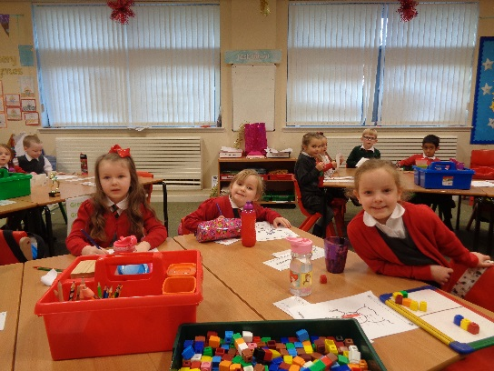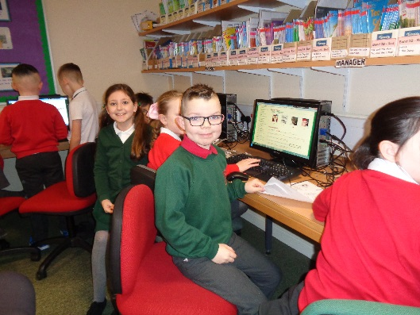

**11. School policies and practical information**

**Free School Meals**

Children of parents who receive the following benefits are entitled to a free lunchtime meal for their child

* Income Support, Universal Credit (where your take home pay is less than £610 per month), Job Seeker’s Allowance (income based), Employment and Support Allowance (income related), Working Tax Credit and Child Tax Credit (where your gross annual income does not exceed £6,420 as assessed by the HM Revenues and Customs), Child Tax Credit Only (where your gross annual income does not exceed £16,105 as assessed by the HM Revenues and Customs) or receive support under Part VI of the Immigration and Asylum Act 1999.

We would encourage parents of children who are in receipt of any of the above benefits to take up this opportunity of having a meal provided for their child when they are at school. Arrangements are in place so that children who receive free meals are not singled out and we encourage all children to remain in school at lunch time.

Healthy eating is something that the school supports and a range of meals are available at lunchtime that meet the Schools (Health Promotion and Nutrition) (Scotland) Act 2007 and the Nutrient Requirements for Food and Drink in Schools (Scotland) Regulations 2008.

All meals include fresh chilled drinking water and milk will be available for those learners entitled to free school meals through the free school meal eligibility scheme at morning break or lunchtime.

Milk is also available for purchase to those learners wishing to buy at breakfast service, where applicable, morning break and lunchtime.

Learners in:

* Primary 1 - 3 receive a free school lunch.
* Primary 4 - 7 meal cost is £1.60

Milk is available free of charge to all nursery age children and is provided by the establishment.

South Lanarkshire Council provides fruit to P1 and P2 children 3 days per week to a selection of schools within the South Lanarkshire area.

**School uniform**

We ask all parents/carers to support the school by encouraging your child(ren) to adhere to the agreed dress code and the wearing of our school uniform. The wearing of a school uniform helps promote the identity of the school in the local community and helps create an ethos of sharing and pride in the school.

In addition, the wearing of a uniform helps towards increasing the protection of all learners. The wearing of a uniform helps staff and the learners to distinguish between who belongs to the school and those who may be visitors. This enables staff to approach and identify visitors more readily and helps in trying to offer a safer environment for learners and teachers alike.

Equality of opportunity is an important aspect of the life of the school. Any proposals on the dress code and on what constitutes the school uniform will be the subject of discussion with the Parent Council and where appropriate consultation with parents, learners and staff.

There are forms of dress which are unacceptable in all schools such as:

* the wearing of football colours
* clothing with slogans that may cause offence (anti-religious, symbolism or political slogans)

1. clothing which advertises alcohol, tobacco or drugs
2. clothing which can be deemed unsuitable in terms of health and safety grounds such as shell suits, combat style clothing, dangling earrings, loose fitting clothes particularly in practical classes
3. articles of clothing that could be deemed to inflict damage on other learners or be used by others to do so
4. footwear that may damage flooring.

The following list may be helpful to parents when choosing clothing suitable for school.

Skirts/Pinafores/Trousers - grey

Shirt - white

Polo Shirt - white/red

Sweater/Cardigan/ Sweatshirt - red/green

School Tie

Our new building is fully carpeted and, in order to keep them clean, **all children must have a separate pair of soft indoor sand shoes or trainers which will be stored in school**. Every child has an individual shoe storage box. Please ensure names are on all items of clothing, in particular sand shoes and outdoor jackets.

j0212309**Physical Education**

T-shirt, gym shorts, gym shoes.

In the case of Pl, 2, 3 gym shoes without laces are desirable.

Jewellery **must be removed** for P.E. and is left in box provided, at own risk.

**Allergies**

**PEANUTS AND NUTS**

Allergies in this school are taken very seriously. If your child needs medical help you may contact our office on 01698 283401 and they will take care of your child. This is a nut free school because many children have allergies. We also do not accept peanut butter and chocolate nut spread. The cafeteria also does not include these in ANY school meals. **By Morgan, P7**

Allergies can present in a variety of ways and can occur at any point in a person’s life. Symptoms range from mild to severe. Children and young people known to have an allergy with moderate to severe symptoms will likely have a Health Care Plan drawn up by the NHS. This will detail symptoms and appropriate interventions.

It is vital that parents share this information with the school and continue to provide any updated information.

Where symptoms are mild and a Health Care Plan is not in place, parents should still continue to liaise regularly with the school on any new triggers, medications and actions required.

In all cases, our employees need to know your child’s symptoms, treatments and any actions required to help prevent exposure to the allergen and minimise the risk of allergic reactions.

Employees in schools will receive training on allergies and will liaise with parents and NHS on any additional specialist training required.

In supporting children and young people with allergies, school employees will operate in accordance with South Lanarkshire Council’s Safe Systems of Work / risk assessment and national guidance on the administration of medicines.

**Support for Parents / Carers**

**Clothing grant**

In certain circumstances the Council provides support to parents/carers for the purchase of school wear.

Applications can be made online at [www.southlanarkshire.gov.uk](http://www.southlanarkshire.gov.uk). If you are required to submit evidence of your Tax Credit income it is important that a copy of this evidence is attached to your online application. Should you require further information or you are unable to submit an application online then please contact the helpline number **0303 123 1011** (option 5).

**School Hours / Holiday Dates**

Opening 9 a.m.

Morning Interval 10.40 - 10.55 a.m.

Lunch Break 12.35 - 1.20 p.m.

Close 3 p.m.

**The School Year**



**Education Resources**

School holiday Dates Session 2019/2020

|  |  |  |  |
| --- | --- | --- | --- |
| Break | Holiday dates | | |
| **First Term** | ***Teachers In-service*** | ***Tuesday*** | ***13 August 2019*** |
|  | ***In-service day*** | ***Wednesday*** | ***14 August 2019*** |
|  | Learners return | Thursday | 15 August 2019 |
| September Weekend | Close on  Re-open | Thursday  Tuesday | 26 September 2019  1 October 2019 |
| October Break | Close on  Re-open | Friday  Monday | 11 October 2019  21 October 2019 |
|  | ***In-service day*** | ***Monday*** | ***18 November 2019*** |
| Christmas | Close on  Re-open | Thursday  Monday | 19 December 2019  6 January 2020 |
| **Second Term** |  |  |  |
| February break | Close on  Closed on | Friday  Monday and  Tuesday | 7 February 2020  10 February 2020  11 February 2020 |
|  | ***In-service day*** | ***Wednesday*** | ***12 February 2020*** |
| Spring break/Easter | Close on  Re-open | Friday  Monday | 3 April 2020  20 April 2020 |
| **Third Term** |  |  |  |
| Local Holiday | Closed | Monday | 4 May 2020 |
|  | ***In-service day*** | ***Tuesday*** | ***5 May 2020*** |
| Local Holiday | Close on  Re-open | Thursday  Tuesday | 21 May 2020  26 May 2020 |
| Summer break | Closed | Thursday | 25 June 2020 |
| Proposed in-service  days | *Proposed date for teachers return (subject to consultation) | | |

Notes

* Good Friday falls on Friday, 10 April 2020
* *Lanark schools will close 11 and 12 June 2020*
* Schools will close at 2.30pm on the last day of terms 1 and 2

(Thursday, 19 December 2019 and Friday 3 April 2020)

* Schools will close at 1pm on the last day of term 3 (Thursday 25 June 2020)

*Two in-service days proposed for August 2020 to be confirmed.

**Enrolment – how to register your child for school**

If your child is starting school for the first time you must enrol your child at their catchment school in January. If parents want their child to go to another school, they must enrol in the first instance with their catchment school and ask for an information leaflet that provides details on how to make a placing request. Forms are available from the SLC website – [www.southlanarkshire.gov.uk](http://www.southlanarkshire.gov.uk), schools, Q and A offices or by contacting Education Resources, Almada Street, Hamilton, telephone 0303 123 1023. Completed forms should be returned as soon as possible to Education Resources, Almada Street, Hamilton ML3 0AE.

Enrolment week for 2019 is 16-18 January 2019.

**P1 Entrant Programme**

In order to help our new Pl entrants and their parents feel more comfortable about coming to school, you will be invited on 29 and 30 May 2019 to meet staff and learners and to find out more about school activities. Some Pre-5 centres are visited throughout the year by members of staff to help establish and maintain good communication links.

Primary 1 learners attend full time, 9.00 am – 3.00 pm, from Thursday 16 August 2019.

**Transport**

(i) **School transport**

South Lanarkshire Council has a policy of providing school transport to primary learners who live more than one mile by the recognised shortest walking route from their catchment school. This policy is more generous than the law requires. This means that the provision of transport could be reviewed at any time. Parents who consider they are eligible should obtain an application form from the school or Education Resources, Hamilton, telephone 0303 123 1023 or web [www.southlanarkshire.gov.uk](http://www.southlanarkshire.gov.uk). These forms should be completed and returned before the end of March for those learners starting the school in August to enable the appropriate arrangements to be made. Applications may be submitted at any time throughout the year and will be considered by Education Resources.

A paid privilege transport scheme is operated for mainstream school contracts where a pupil is not entitled to free school transport. Privilege transport will only be granted providing there is spare capacity on an existing school contract and will be from and to designated pick up and drop off points. Privilege transport will not be provided where a service bus is used on the school run. Any spare capacity will be allocated using agreed priorities. For more information on school transport contact Education Resources telephone 0303 123 1023.

(ii) **Pick-up points**

Where school transport is provided it may be necessary for learners to walk a certain distance to the vehicle pick-up point. Walking distance in total, including the distance from home to the pick-up point and from the drop-off point to the school in any one direction, will not exceed the authority’s distance limit for school transport.

It should be noted that it is the parent’s responsibility to ensure their child behaves in a safe and acceptable manner while travelling in and alighting from the vehicle. Misbehaviour can result in your child losing the right to school transport.

Parents are asked to note that South Lanarkshire Council does not provide transport for those learners who attend school via a placing request. Where there is a request to place a child under school age in a school within the local catchment area they may receive transport in line with the Council’s transport policy.

**Insurance for schools – learners’ personal effects**

South Lanarkshire Council is concerned at the level of claims being received for loss or damage to learners’ clothing or personal effects. Parents are asked to note the Council’s position in terms of insurance for learners’ personal effects:

(i) **Theft/loss of personal effects**

The Council is not liable for the loss or theft of learners’ clothing or personal effects and any items are therefore brought into the school at the pupil/parents’ own risk.

Parents can assist by ensuring that valuable items and unnecessarily expensive items of clothing are not brought to school.

Teachers and other staff have been advised not to accept custody of any such items.

The same principle applies to musical instruments and other equipment used for activities within the school, which belong to the pupil, but are brought into the school. Parents should be aware that if such equipment is left in school, it is done at the pupil/parents’ own risk.

In the case of valuable items such as musical instruments, parents should ensure that these items are covered by their own household insurance.

(ii) **Damage to clothing**

The Council is only liable for damage caused to learners’ clothing where the damage has resulted from the negligence of the Council or one of its employees. Claims arising otherwise will not be accepted by the Council’s insurers.

**Family Holidays During Term Time**

Every effort should be made to ensure that your child attends school during term time. Please contact the school as soon as possible if your child is unable to attend school.

Family holidays should be avoided during term time as this both disrupts the child’s education and reduces learning time. If holidays are taken during times when the school is open parents should inform the school in advance by letter.

If your child is taken on a family holiday during term time then in line with Scottish Government advice this will be classified as an unauthorised absence. However, in exceptional circumstances schools may register a family holiday during term time as an authorised absence when for example, parents are unable to obtain leave during the school holiday period.

Clearly, absence with no explanation from parents will mean that the absence will be recorded as unauthorised.

In our approach to raising attainment and achievement it is recognised that attendance at school is something that should be continuously encouraged. Parents/carers, children and the school all have a part to play in encouraging and stressing the importance of attendance at school.

The school holiday dates and in-service dates are available from the website [www.southlanarkshire.gov.uk](http://www.southlanarkshire.gov.uk)

**Promoting Positive Behaviour**

It is the responsibility of staff within the school to ensure that parent council members, parents and learners are involved in the creation of a positive school ethos that encourages good behaviour. Equally, the school whilst trying to promote positive behaviour must support young people should incidents or bullying occur. Parents have a significant role to play in working with the school so that teachers, parents and learners know what is expected of them in trying to change the behaviour and attitudes that contribute to bullying behaviour.

Our approach is to create an environment where better behaviour will encourage better learning. The school, along with the support of parents, can work together to create a learning environment which young people can enjoy and feel safe.

Incidents of bullying should be reported to the school immediately so that each alleged incident can be looked at. Together we can work towards creating a safer school for children and staff.

In addition, a guideline (Promoting Positive Relationships and Behaviour) has been produced to support all teaching and support staff and inform them of their roles and responsibilities in respect of dealing with the small number of children and young people who display challenging behaviour. Early identification is crucial so that intervention can be provided to support children and young people to help them address their issues and concerns. Staff training is provided to help develop the skills needed to respond to and manage challenging behaviour. A wide range of appropriate staff development opportunities has been developed for this purpose.

**Child Protection**

All staff in educational establishments in South Lanarkshire Council are required to receive an annual update and follow the advice and guidance contained within the Education Operating Procedures.

The shared vision for Lanarkshire’s children is: “all children and young people in Lanarkshire have the right to be cared for and protected from abuse and harm in a safe environment in which their rights are respected.” All agencies will work together in a collaborative way to promote the safety and wellbeing of children and young people in Lanarkshire.

The Chief Officers and Child Protection Committees of North and South Lanarkshire Council’s are the driving force for ensuring that agencies individually and collectively work to protect children and young people as effectively as possible.

The Council has a duty in law to report suspicions that a child has been abused or is at risk of harm, in terms of the Children (Scotland) Act 1995. Therefore, Council staff have a professional and contractual obligation to report concerns to the head of establishment or the child protection coordinator immediately.

Education Resources staff and visitors from other agencies and services are required to follow these Child Protection Procedures to protect and support children and to fulfil their professional obligations to report all allegations or suspicions of child abuse.

For more information, or if you have a concern of a child protection nature, please contact the head of the educational establishment which your child attends.

**Keeping Safe online**

The Council has produced an information leaflet – ‘stay safe’ for parents/carers on how to help ensure their child is safe when using the internet and mobile devices.

Copies are available from the school or the web:[**www.southlanarkshire.gov.uk**](http://www.southlanarkshire.gov.uk)

**Information on emergencies**

We make every effort to ensure the school remains open during term-time for learners. However, on occasions circumstances may arise which can affect the school. Schools may be affected by, for example, severe weather, power failures or through any other circumstances that may impact on the school day. In such cases we shall do all we can to let you know if this happens. We shall keep you in touch by telephone, text, where appropriate, letters, web news and through local radio stations particularly if there are prolonged periods of severe weather. The Council’s website [www.southlanarkshire.gov.uk](http://www.southlanarkshire.gov.uk) will be used to let you know if the school is closed and when it will re-open.

It is important for parents/carers to let the school know of any change to your mobile/home telephone number and change of address.

If for any reason, you are unsure if the school is open, please contact the school or Education Resources, Operations Service, Almada Street, Hamilton. (Telephone 0303 123 1023 ) or email us at: [education@southlanarkshire.gov.uk](mailto:education@southlanarkshire.gov.uk) or visit the website [www.southlanarkshire.gov.uk](http://www.southlanarkshire.gov.uk)

**Your commitments**

We ask that you:

* support and encourage your child’s learning
* respect and adhere to the schools policies and guidance
* let the school know if you change your mobile/telephone number and/or address
* enjoy and take part in school activities
* accept your responsibility to respect staff who work in the school and for the school to be proactive in taking forward its commitment to care for and educate your child.

**Data Protection Act 1998**

Information on learners, parents and guardians is held by the school to enable the teaching, registration and assessment of learners as well as associated administrative duties. The information is stored and used as per the requirements of the Data Protection Act 1998 with South Lanarkshire Council defined as the data controller. The Council have established a data protection policy that applies to all of its schools. For more information please contact the school.

**Appendix A**

**This annex gives a list of useful information and the links to the content is now available from the Council’s website by accessing the following link**

[**http://www.southlanarkshire.gov.uk/info/200186/primary_school_information/1264/curriculum_for_excellence/3**](http://www.southlanarkshire.gov.uk/info/200186/primary_school_information/1264/curriculum_for_excellence/3)

**The list is not intended to be exhaustive and authors may wish to consider additional sources of school, local and national information, material and resources.**

**Contact Details**

Education Scotland’s Communication Toolkit for engaging with parents

The Scottish Government guide Principles of Inclusive Communications provides information on communications and a self-assessment tool for public authorities

Choosing a School: A Guide for Parents - information on choosing a school and the placing request system

A guide for parents about school attendance explains parental responsibilities with regard to children’s attendance at school

**Parental Involvement**

Guidance on the Scottish Schools (Parental Involvement) Act 2006 provides guidance on the act for education authorities, Parent Councils and others

Parentzone provide information and resource for parents and Parent Councils

**School Ethos**

Supporting Learners - guidance on the identification, planning and provision of support

Journey to Excellence - provides guidance and advice about culture and ethos

Health and wellbeing guidance on healthy living for local authorities and schools

Building Curriculum for Excellence Through Positive Behaviour and Relationships outlines the Scottish Government’s priority actions around positive behaviour in schools and is also a source of support

Scottish Catholic Education Service’s resource ‘This is Our Faith’ which supports the teaching and learning of Catholic religious education

**Curriculum**

Information about how the curriculum is structured and curriculum planning

Information about the outcomes a learner can expect to experience and achieve across literacy, numeracy and health and wellbeing, as well as the 8 curricular areas

Advice, practice and resources to support the experiences and outcomes on literary, numeracy and health and wellbeing

Broad General Education in the Secondary School – A Guide for Parents and Carers

Information on the Senior Phase

Information on Skills for learning, life and work

Information around the Scottish Government’s ‘Opportunities for All’ programme

Information for organisations responsible for the planning, management and delivery of career information, advice and guidance services

The Skills Development Scotland website ‘My World of Work’ offers a number of tools to support career planning

**Assessment and Reporting**

Building the Curriculum 5: a framework for assessment provides guidance around the assessment framework

Information about Curriculum for Excellence levels and how progress is assessed

Curriculum for Excellence factfile - Assessment and qualifications

Information on recognising achievement, reporting and profiling

**Transitions**

Curriculum for Excellence factfile - 3-18 Transitions - provides information on the transitions children and young people will face throughout their education and beyond

Career Information, Advice and Guidance in Scotland - A Framework for Service Redesign and Improvement provides guidance on career information, advice and guidance strategy

Choices and changes provides information about choices made at various stages of learning

The Additional support for learning page provides links to relevant legislation and guidance, including the arrangements that should be in place to support learners with additional support needs

Supporting Children's Learning Code of Practice includes specific requirements on education authorities and others under the new legislation in relation to transition

Enquire is the Scottish advice service for additional support for learning

Parenting Across Scotland offers support to children and families in Scotland

**Support for Learners**

The Additional support for learning page provides links to relevant legislation and guidance, including the arrangements that should be in place to support learners with additional support needs

Information about the universal entitlement to support that underpins Curriculum for Excellence

Supporting Children's Learning Code of Practice (Revised edition) - provides Statutory guidance relating to the Education (Additional Support for Learning) (Scotland) Act 2004 as amended

Getting It Right For Every Child and Young Person, is essential reading for anyone involved or working with children and young people, including practitioners working in adult services with parents and carers

**School Improvement**

Scottish Schools Online - provides a range of school information, including contact details, school roll, facilities, website, inspection reports

Education Scotland’s Inspection and review page provides information on the inspection process

The Scottish Survey of Literacy and Numeracy (SSLN) is an annual sample survey which will monitor national performance in literacy and numeracy

Scottish Credit and Qualifications Framework (SCQF)

Scottish Qualifications Authority provides information for teachers, parents, employers and young people on qualifications

Amazing Things - information about youth awards in Scotland

Information on how to access statistics relating to School Education

**School Policies and Practical Information**

**National policies, information and guidance can be accessed on the following:**

Education

Health

Young People

Children (Scotland) Act 1995

Standards in Scotland's Schools (Scotland) Act 2000